2.

a) Downloaded and with the help of this solved question C.

b) After running code in file plot.R, we will get below charts,

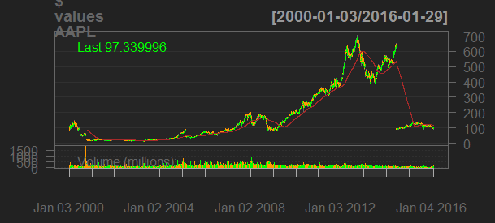

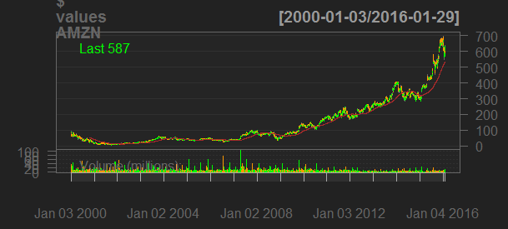

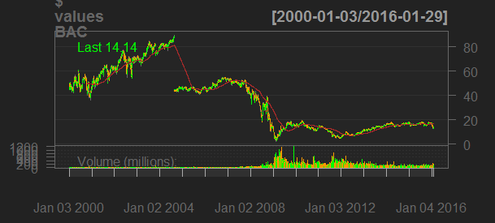

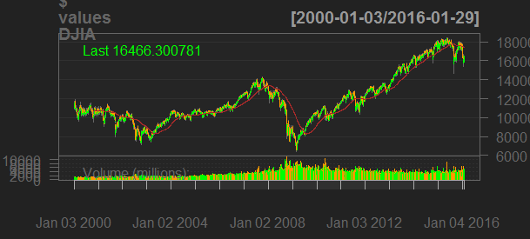

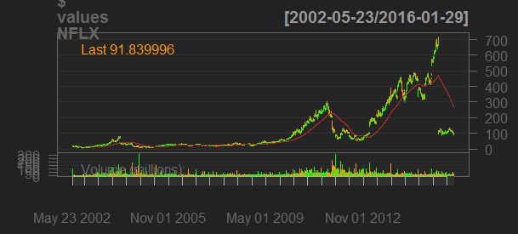

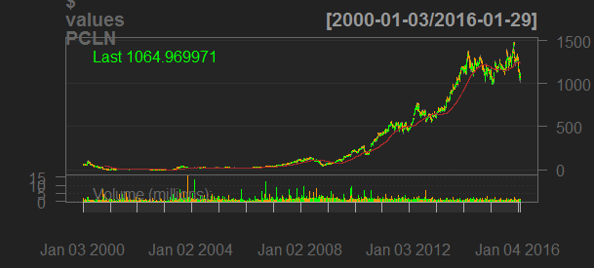

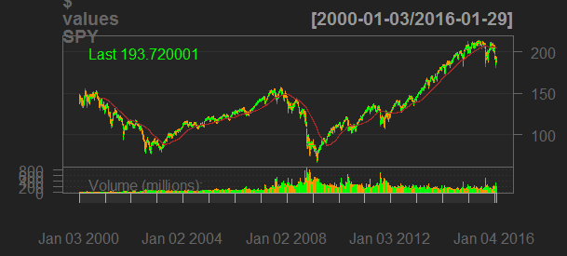

c).

|  |  |  |  |  |
| --- | --- | --- | --- | --- |
| Stock | Buy Hold | | SMA Crossover | |
| CAGR | Performance | CAGR | Performance |
| DJIA | 2.7 | 1.53 | 1.6 | 1.29 |
| AAPL | -0.4 | 0.94 | 9.2 | 4.08 |
| BAC | -6.4 | 0.35 | -6.8 | 0.33 |
| NFLX | 15.2 | 6.83 | 24.4 | 19.61 |
| PCLN | 22.2 | 24.88 | 23.8 | 30.60 |
| AMZN | 13.5 | 7.56 | 16.7 | 11.86 |

As per the above result in the table we can see that performance of SMA crossover is better than Buy Hold, hence I would choose SMA crossover over Buy Hold.

Also Buy hold is passive investment strategies which is not good for short term price movements and technical indicators.